**Phylogenetic analysis**

|  |  |  |  |  |  |
| --- | --- | --- | --- | --- | --- |
|  | **NJ MODEL** | **KIMURA 2-PARAMETER MODEL** | **TAMURA 3** | **Jukes-Cantor method** | **TAMURA NEI** |
| **How many bootstrap reliable nodes are there in your output?** | 2 | 1 | 1 | 1 | 1 |
| **Highest bootstrap value** | 97 | 97 | 97 | 97 | 96 |

**Are more reliable nodes found near the base of the tree, that is towards this end of the tree or towards the terminal tips of the tree? Can you guess the reason?**

In all of them, more reliable nodes are found in the middle.

Reason : Common ancestry between the clades, but the descendants of that common ancestors are not that similar.

**Do the relationship between sequences change with different tree presentation styles? (open the tree session file in Mega, go to view and change the style to radial or circular)?**

* No, the relationship remains the same.

**Does the relationship between the taxa change by changing the root? (open the tree session file in Mega, go to view, choose the option root, click on the branch you want to make the root as)**

* Yes but the relationship between the clades remained the same.

**What is the difference in the root for the traditional rectangular pattern Vs Circular pattern representation?**

* **TRADITIONAL RECTANGULAR PATTERN :**

Any branch of the tree can be converted into a root.

Used where precise knowledge of branch lengths is important. The branch length represents the evolutionary time between two nodes.

**CIRCULAR PATTERN :**

Can’t convert any branch to a root.

Usedwhere precise knowledge of branch lengths may be less important.

**Which Substitution model gives a higher confidence level with your data?**

* Considering the number of reliable nodes, neighbor joining model gives higher confidence level when compared with others.

**Neighbor Joining**

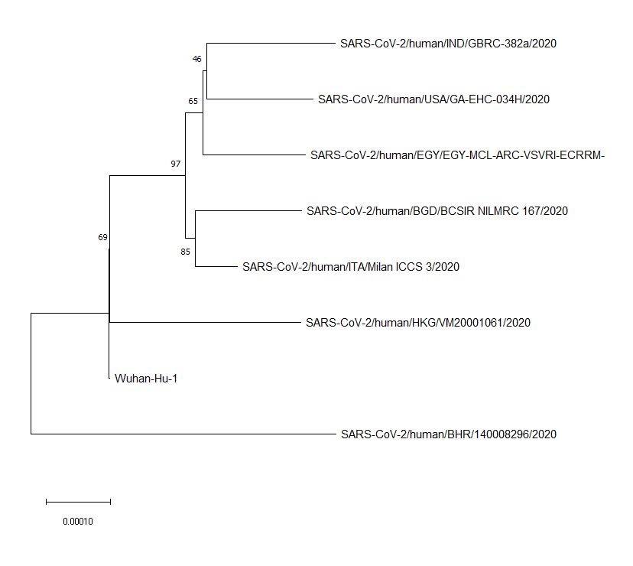

**Kimura-2**

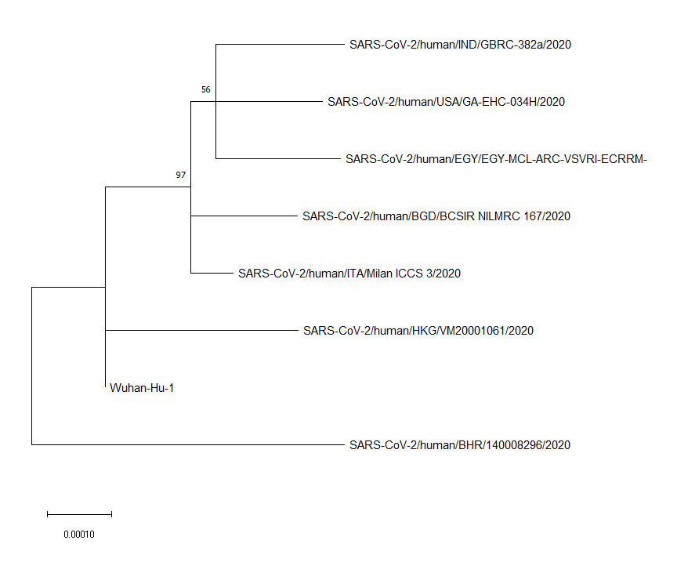

**Tamura -3**

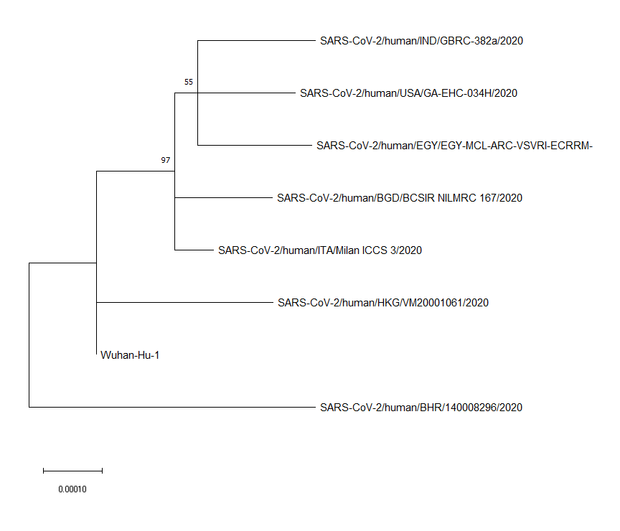

**Jukes Cantor**

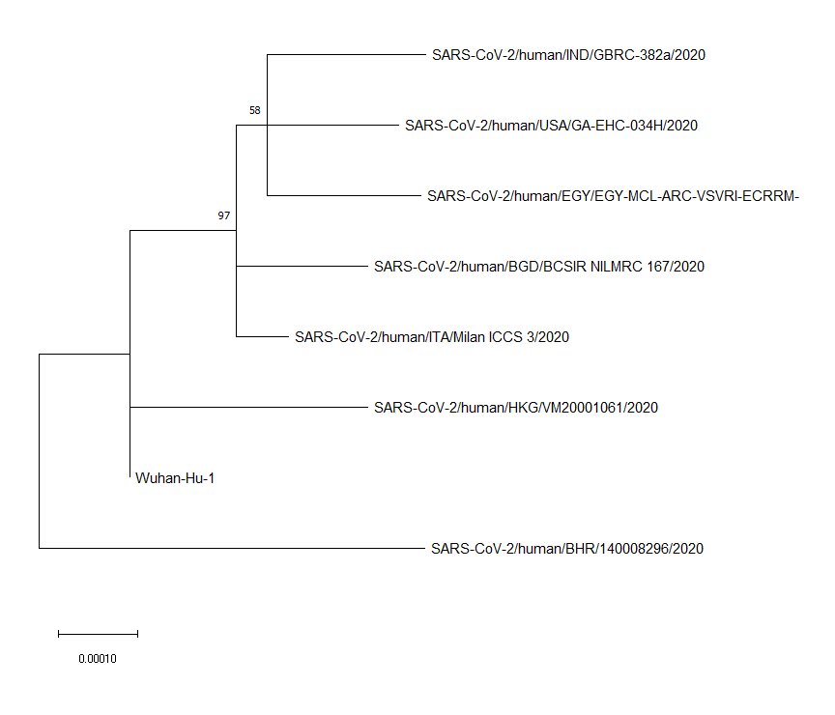

**Tamura Nei**

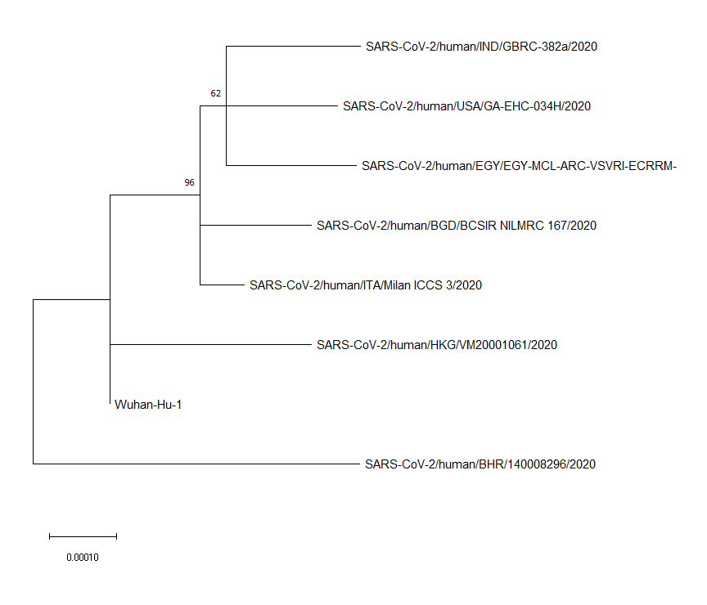

**ANALYSIS :**

1. The relationship between the different trees are almost the same.
2. Bahrain’s strain is an outgroup, more distantly related with others.
3. CLADES:

CLADE-1 : INDIA, USA,EGYPT

CLADE-2 : BANGLADESH, ITALY

1. Throughout the model, the most reliable node is the common ancestor between clade1 and clade2.
2. Closely related strains:

* Wuhan-Hong Kong
* Italy-Bangladesh
* India-USA-Egypt

Bootstrap values for them are very less, hence, they are not reliable.